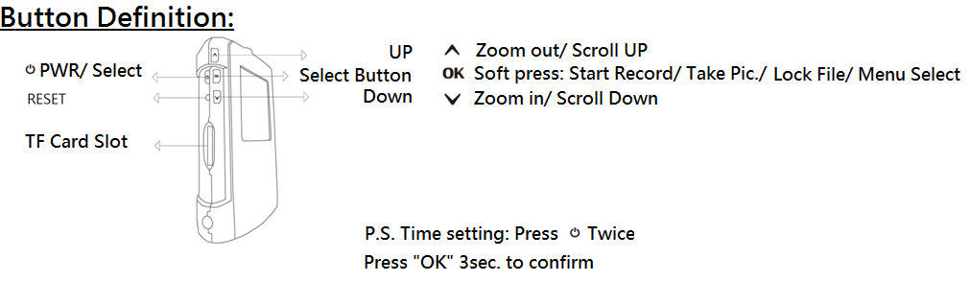
- Introduction
This detailed user manual is aimed at helping you understand how to use the device. Please read it before you operate the device for the first time. We have the right to change the content at any time. A warranty will not be provided to due to any act of God, misuse, abuse, negligence, or modification of the device.

■ Installation
◇ Please choose most suitable place for installation where there is no obstacle interruption
◇ Please do not touch the lens with your fingers; it may lead to blurry images as fingerprints can leave smears
◇ Clean the lens regularly

■ Looking after the device
★ Do not disassemble or attempt to repair the device
★ Keep the device away from fire
★ Do not operate the device while moving. Make sure you comply with your country’s laws and overall traffic safety when operating the device

■ Precautions
． Store the device at room temperature in a dust-free environment
． Storing the device at high temperatures may shorten battery life or melt plastic parts and extreme cold can damage circuits as moisture can form inside it when it returns to a normal temperature
． Do not repair the device yourself. If it appears faulty please take it to an authorized dealer
． Do not drop the device as it may cause internal components to malfunction
． Use a damp cloth to clean the device, do not use chemical detergents

■ Specification
◆ 150 degree wide-view angle lens
◆ 1920 x 1080P FULL HD at 30fps
◆ Photo quality: 4032x3024 pixels
◆ 4 x digital zoom camera
◆ 2.0”LCD screen that can display video and pictures at the same time
◆ SOS file lock supported
◆ G-Sensor supported
◆ Files will be secured even in a sudden shut-down
◆ HDMI and USB ports supported
◆ Seamless, cyclic and time interval recording
◆ User-friendly interface
◆ Support max. 64GB; prefer C6 and above memory card

- 》1. Icon key
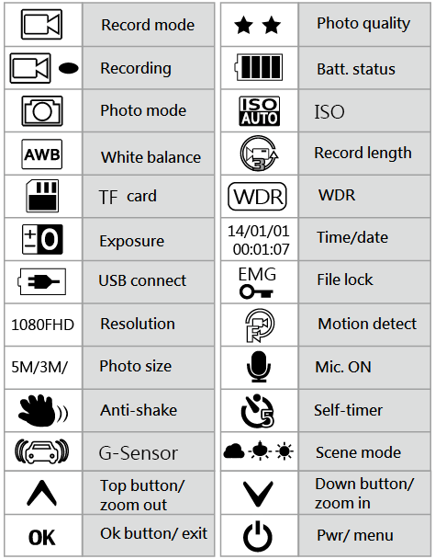

》2. Lights
Yellow light----Battery charging
Blue light ----Recording
Red light ----Standby

》3. Function selection
■ Video menu
1. Resolution
1080FHD (1920x1080),720P (1280x720),
WVGA (848x480P), VGA (640x480)
2. Recording intervals: OFF/1min/3min/5min
3. Exposure: +2.0 +5/3 +4/3 +1.0 +2/3 +1/3 +0.0 -1/3 -2/3 -1.0 -4/3 -5/3 -2.0
4. Motion detect: OFF/ON
5. Sound record: OFF/ON
6. Time stamp: OFF/ON

■ Settings
1. Date/time: 2013/01/01 - 12:00:00 – YY/MM/DD
(Press OK for 2 seconds once confirmed)
2. Sound: ON/OFF
3. Language: English/Simplified Chinese/Traditional Chinese/Russian/Japanese/French/Spanish/
Portuguese/German/Italian
4. TV output: PAL/NTSC
5. Frequency: 50HZ/60HZ
6. Format: Cancel/confirm
7. Factory setting: Cancel/confirm
8. Screen saver: OFF/3min/5min/10min
9. Ver.: Display current version

■ Photo mode: Long press OK for 3 seconds to enter, then press once to shoot
■ Photo setting: Soft press PWR
1. Photo selection: single/2sec. self-timer/5sec. self-timer/10sec. self-timer
2. Resolution
12M 4032x3024/10M3648x2736/8M3264x2448/
5M2592x1944/3M2048x1536/2MHD1920x1080/
VGA640x480/1.3M1280x960
3. Continuous shoot: OFF/ON
4. Photo quality: Best/Standard/Low
5. Sharpness: Strong/Standard/Soft
6. White balance: Auto/White/Cloudy/Lightbulb
7. Colour effect: Colour/Black & White/Retro
8. ISO: Auto/100/200/400
9. Exposure: +2.0 +1.7 +1.3 +1.0 +0.7 +0.3 +0.0
-0.3 -0.7 -1.0 -1.3 -1.7 -2.0
10. Anti-shake: OFF/ON
11. Date/time record: OFF/Date/Date&Time

■ Play mode: Long press OK for 3 seconds, then press TWICE to play
1. Delete: Current file/All file (press PWR to enter)
2. Protect file: Protect current file/Unprotect current file/Protect all files/Unprotect all files
3. Slideshow: OFF/Confirm/8 seconds

■ Operating guide
1. Charging the battery
Main unit battery can use either a USB port or connect to a power source for charging.

2. Connecting to 12V/24V motorbike charger port
This will allow the DVR to automatically record once the engine has started. You can select interval recording of either 1, 3 or 5 minutes. Once the engine is turned off, the DVR will automatically stop recording and save your files.

Note: Please only use the power charger that comes with the 12V/24V step-down voltage regulator to 5V!

3. TF card installation
[1] Make sure the TF card is inserted the right way up
[2] Use SDHC spec TF card Class 6 and above
[3] Format TF card first when using a new card with the device

4. Time and date settings
Once the device is ON, press twice to enter the time/date menu then press UP or DOWN. Press OK to access the next setting. Once all settings are confirmed press OK for 2 seconds.

5. Language settings
Once the device is ON, press twice to enter the language menu then press UP or DOWN to select the required language. Once finished, press OK to confirm.

6. Recording ON/OFF
Press PWR for 3 seconds to enter recording mode

7. Recording mode
[1] Resolution select: Press『』 to enter menu:
1080P FHD (1920X1080P)/720P (1280X720P)/
WVGA (848X480P)/VGA (640X480P)
[2] Press『OK』to start recording and press OK to stop recording. When the device is recording the screen will show the icon『.

8. Camera mode
[1]. Camera is 4032x3024pixels。
[2]. Soft press『OK』to start taking pictures

9. Play mode
[1]. Long press『OK』to enter play mode. Long press『OK』again to enter picture play mode.
Long press『OK』to enter video play mode.
[2]. Either during picture or video play mode, you can press『UP or DOWN』to select the files to view. Press『OK』to PLAY or STOP.
[3]. During play mode, soft press『』 to enter the menu to delete/ protect/slideshow files. Once selected press『OK』to confirm.

10. File protect/ unprotect
[1]. Soft press『』to enter the selection of either protect/ unprotect the current file. All protected files will show the icon, which cannot be deleted unless unprotected.
[2]. G-sensor auto file protect. The G-sensor will activate if there is a sudden hard bump to protect your files. The file protected will be the one being recorded; the screen will display .
[3]. SOS file protect. During recording you can manually protect your file by long pressing『 OK .』The file protected will show theicon.

11. Interval recording

OFF/1min/3min/5min
When OFF is selected.
[1]. The TF card will not overwrite the memory during this selection. The system will tell you when the card is full or cannot be overwritten. If this happens, therefore the memory card needs to be formatted,

Select either 1min/3min/5min
[1]. The TF card can be overwritten once the memory is full; it will not overwrite the protected files.

12. Time/Date stamp
Either ON/OFF

- Product specification
Sensor AR 0330 CMOS Sensor
Display 1.5″LCD
Chipset Made in Taiwan
TF card Max. 64GB and C6 or above
Lens Japan A grade glass lens
Still image Format：JPEG（EXIF2.2）DCF
Resolution：12M 4032x3024/10M3648x2736/8M3264x2448/5M2592x1944/
3M2048x1536/2MHD1920x1080/VGA640x480/1.3M1280x960
Video file MOV (H.264)
Resolution
1080FHD (1920x1080)/1080P (1440x1080)/ 720P(1280x720)/
WVGA (848x480P)/VGA (640x480)/ QVGA (320x240)
Zoom Recording mode: 4 x zoom (1280×720 30fps)
Picture mode: 8 x zoom
Sound Built-in speaker
Exposure -2.0EV~+2.0EV
SOS Supported
Record interval OFF, 1min, 3min, 5min
USB Port USB2.0
Video output AV port：NTSC/PAL
HDMI supported
Power Built-in rechargeable lithium battery
Operating temp. -25° to 75° Celsius

- Troubleshooting
◎Cannot record or take a photo
Examine TF card and check if the memory is full or if there are too many protected files
◎During recording, device stops by itself
We recommend high speed SDHC with Class 6 and above memory card
◎When playing back files, status says file corrupted
This error occurs when the memory has the wrong storage file type. Please format the card.
◎No display via TV screen
Confirm AV or HDMI cable is connected correctly and make sure the TV is set to AV or HDMI status。
◎Playback files are fuzzy or blurry
This can happen if the lens is not clean (dirt or fingerprints). Clean the lens with a damp cloth.
◎Picture shows either horizontal or vertical interference
The wrong frequency is selected, select 50Hz or 60Hz
◎Device stops auto recording, when STOP is pressed it starts recording again
Please check if motion detect is ON (the motion detect logo will be displayed on the screen)
◎The device has crashed
Press the RESET button

- Accessories
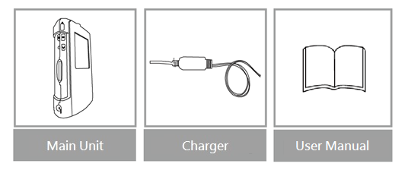

Made in Taiwan

